ProjectDesignPhase-Il

TechnologyStack(Architecture&Stack)

|  |  |
| --- | --- |
| **Date** | **24October2022** |
| **TeamID** | **PNT2022TMID20647** |
| **ProjectName** | **DeepLearningFundusImageAnalysisforEarlyDetectionofDiabeticRetinopathy** |
| **Maximummarks** | **4marks** |

TechnicalArchitecture:

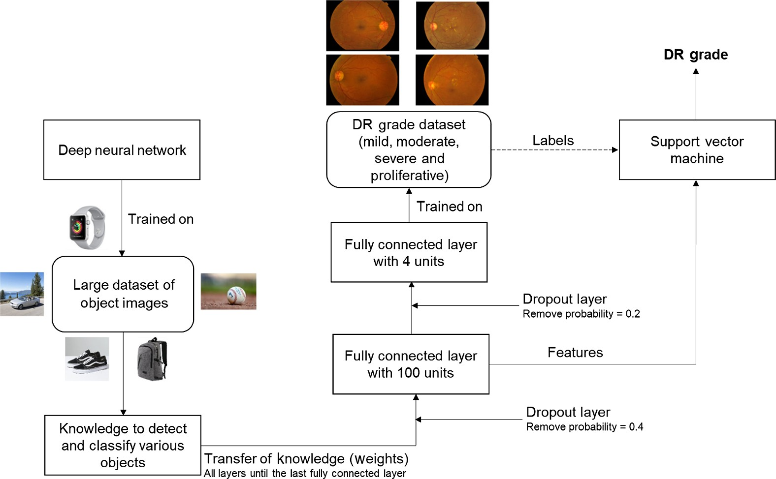

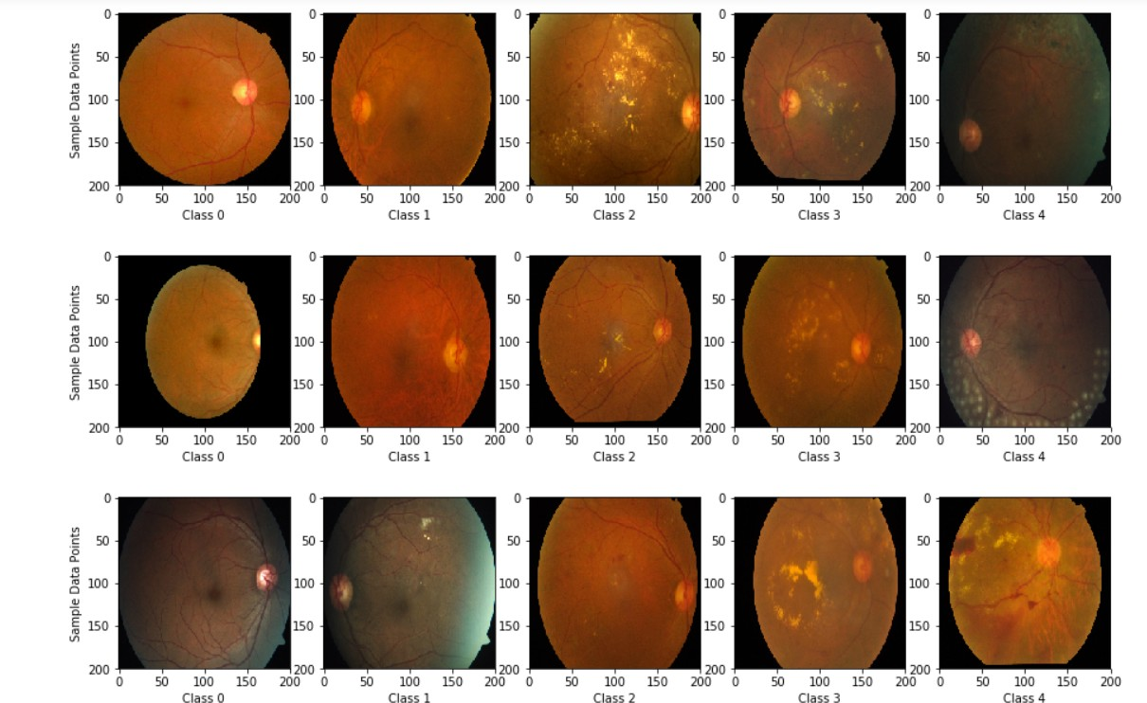

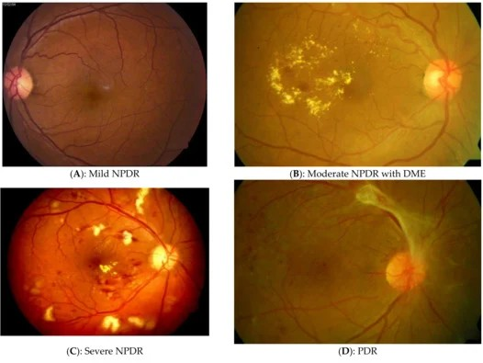

Table-1:Components&Technologies:

|  |  |  |  |
| --- | --- | --- | --- |
| S.NO | Component | Description | Technology |
| 1 | UserInterface | How user interacts with application e.g.WebUI,MobileApp,Chatbotetc. | HTML,CSS,JavaScript/AngularJs/ReactJsetc. |
| 2 | ApplicationLogic-1 | Logicforaprocessintheapplication | Java/Python |
| 3 | ApplicationLogic-2 | Logicforaprocessintheapplication | IBMWatsonSTTservice |
| 4 | ApplicationLogic-3 | Logicforaprocessintheapplication | IBMWatson Assistant |
| 5 | Database | DataType,Conﬁgurationsetc. | MySQL,NoSQL,etc. |
| 6 | CloudDatabase | DatabaseServiceonCloud | IBMDB2,IBMCloudantetc. |
| 7 | FileStorage | Filestoragerequirements | IBM Block Storage or OtherStorage Service or LocalFilesystem |
| 8 | ExternalAPI-1 | PurposeofExternalAPIusedintheapplication | IBMWeatherAPI,etc. |
| 9 | ExternalAPI-2 | PurposeofExternalAPIusedintheapplication | AadharAPI,etc |
| 10 | MachineLearningModel | Purpose of Machine Learning Model | ObjectRecognitionModel,etc. |
| 11 | Infrastructure(Server/Cloud) | Application Deployment on LocalSystem | Local,CloudFoundry,Kubernetes,etc. |

Table-2:ApplicationCharacteristics:

|  |  |  |  |
| --- | --- | --- | --- |
| S.No | Characteristics | Description | Technology |
| 1 | Open-SourceFrameworks | Listtheopen-sourceframeworksused | Technology of Opensourceframework |
| 2 | SecurityImplementations | Listallthesecurity/accesscontrolsimplemented, use of ﬁrewalls etc. | e.g.SHA-256,Encryptions,IAMControls,OWASPetc. |
| 3 | ScalableArchitecture | Justifythescalabilityofarchitecture(3-tier,Technologyused  Micro-services) | Technologyused |
| 4 | Availability | Justifytheavailabilityofapplication(e.g. use of load balancers,distributedserversetc.) | Technologyused |
| 5 | Performance | Design consideration for theperformance of the application(numberofrequestspersec,useofCache,useofCDN's)etc. | Technologyused |